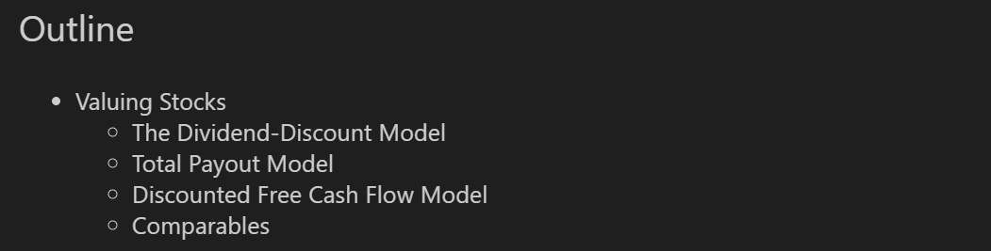

**Stock Valuation**

1. **Dividend Discount Model (DDM)**

* Values a stock as the **present value of all expected future dividends**.
* Useful when firm **pays regular dividends**.
* Assumes either **constant**, **zero-growth**, or **constant growth** in dividends.
* Formulas:

**One – period**

|  |
| --- |
| $$p_{0}=\frac{{Div}_{1}+p_{1}}{1+r_{E}}$$ |

**Constant growth (Gordon)**

|  |
| --- |
| $$p_{0}=\frac{{Div}_{1}}{r_{E}-g}$$ |

Where:

* $p_{0}$: Price today
* ${Div}_{1}$ ​: Dividend next year
* $r_{E}$: Equity cost of capital
* g: Dividend growth rate

|  |
| --- |
| $$r_{E}= \frac{{Div}_{1}+ p_{1}}{p_{0}}-1=\frac{{Div}_{1}}{p_{0}}+\frac{p_{1}-p_{0}}{p_{0}}$$ |

$\frac{{Div}_{1}}{p_{0}}$**: Divident yield**

$\frac{p_{1}-p_{0}}{p_{0}}$**: Capital gain rate**

**A multiyear investor timeline**

* Year 0: Buy the stock, pay price $p_{0}$ (Price today)
* ​Year 1: Receive dividend ${Div}_{1}$ (Dividend next year)
* **Year 2: Receive divident ${Div}_{2}$**  and sell stock at $p_{2}$

**At year 0:**

|  |
| --- |
| $$p_{0}=\frac{{Div}_{1}+p_{1}}{1+r_{E}}$$ |

**But**

|  |
| --- |
| $$p_{1}=\frac{{Div}_{2}+p_{2}}{1+r_{E}}$$ |

**Substitute $p_{1}$ into $p_{0}$:**

|  |
| --- |
| $$p_{0}=\frac{{Div}_{1}}{1+r_{E}}+\frac{{Div}_{2}}{{\left(1+r_{E}\right)}^{2}}+ \frac{P_{2}}{{\left(1+r_{E}\right)}^{2}}$$ |

**General Form of DDM: (g ko ổn định)**

|  |
| --- |
| $$p_{0}=\frac{{Div}_{1}}{1+r_{E}}+\frac{{Div}_{2}}{{\left(1+r_{E}\right)}^{2}}+…+\frac{{Div}_{N}}{{\left(1+r_{E}\right)}^{N}}+ \frac{P_{N}}{{\left(1+r_{E}\right)}^{N}}$$ |

**Infinite Horizon (Stock never sold):**

|  |
| --- |
| $$p_{0}=\sum_{h=1}^{∞}{\frac{{Div}_{n}}{{\left(1+r_{E}\right)}^{n}}}$$ |

* This means the price of the stock is the present value of all expected future dividends.

**Special Case – Perpetuity (Constant Dividend):**

|  |
| --- |
| $$p_{0}=\frac{D_{1}}{r_{E}}$$ |

* Constant dividend forever
* No growth (g = 0)

**Constant dividend growth (perpetuity):**

|  |
| --- |
| $$p_{0}=\frac{{Div}_{1}}{r_{E}-g}$$ |

**Rearranging for $r_{E}$**

|  |
| --- |
| $$r_{E}=\frac{{Div}_{1}}{P_{0}}+g$$ |

**Limitations:   
  
**

**With constant expected dividend growth, the expected growth rate of the share price matches the growth rate of dividends.**

1. **Dividends Versus Investment and Growth**

**A Simple Model of Growth**

|  |
| --- |
| $${Div}_{t}=\frac{{Earnings}_{t}}{Shar{es Outstanding}_{t}}*Dividend Payout {Rate}_{t}$$ |

$Shares {Outstanding}_{t}$**: ${EPS}_{t}$**

|  |
| --- |
| **Dividend payout rate: The fraction of its earnings that a firm pays as div each year** |
| **Change in Earnings = New Investment * ROI** |
| **New investment = Earnings * Retention rate** |
| **Change in Earnings = Earnings * Retention Rate * ROI** |
| $\frac{Change in Earnings }{Earnings}$**= Retention Rate * ROI** |
| **EPS growth (g) = Retention Rate * ROI** |
| **Sustainable Growth Rate: The rate ai which a firm can grow using only retained earnings** |

**Changing Growth Rates**

* Terminal Value at Year N (assuming constant growth g starting Year N+1

|  |
| --- |
| $p_{N}=\frac{{Div}_{N+1}}{r_{E}-g}$**=> This is the Continuation or Terminal Value** |

**Constant Long-Term Growth (g ổn định)**

|  |
| --- |
| $$p_{0}=\frac{{Div}_{1}}{1+r_{E}}+\frac{{Div}_{2}}{{\left(1+r_{E}\right)}^{2}}+…+\frac{{Div}_{N}}{{\left(1+r_{E}\right)}^{N}}+\frac{1}{{\left(1+r_{E}\right)}^{N}}*\left(\frac{{Div}_{N+1}}{r_{E}-g}\right)$$ |

**Limitations of the Dividend-Discount Model**

* **Uncertain Dividends**: Future dividends are hard to predict, especially for firms without stable dividend policies.
* **Sensitive to Growth Rate**: Small changes in assumed growth (g) can cause large changes in stock value.
* **Managerial Discretion (Quyền quyết định của quản lý)**: Earnings, payout ratios, and share counts depend on management decisions, which are hard to forecast.

1. **Total Payout and Free Cash Flow Valuation Models**

**Share Repurchase:**

* When a firm uses excess cash to **buy back its own shares**.
* **Impacts on DDM:**
* The more cash a firm uses to repurchase shares, the less it has available to pay dividends.
* By repurchasing shares, the firm **decreases its share count**, which **increases its earnings** **and dividends on a per-share** basis.

**Total Payout Model**

* Values the entire equity of the firm rather than a single share
* Takes into account **both dividends and share repurchases**

|  |
| --- |
| **Total Firm Value = PV(Future Total Dividends and Repurchases)** |
| $$p_{0}=\frac{PV(Total value)}{{Shares outstanding}_{0}}$$ |
| $$Total value=\frac{Total payout}{r_{e}-g}$$ |

* Discount total dividends and share repurchases; use the growth rate of total earnings (rather than EPS) when forecasting the growth of the firm's total payouts.

1. **The Discounted Free Cash Flow Model (DCF)**

* **Estimate the Enterprise Value** of a firm by discounting its expected future Free Cash Flows (FCF) available to all capital providers (equity + debt holders).

|  |
| --- |
| **Enterprise Value** ($V_{0})$ = Total value of the firm’s core operations |

* Suitable for firms that do not pay dividends or are growing.
* **Market Capitalization:** The market value of the firm's equity, or the value that remains after the firm has paid its debts.

|  |
| --- |
| **Market value of equity = share price × number of shares** |

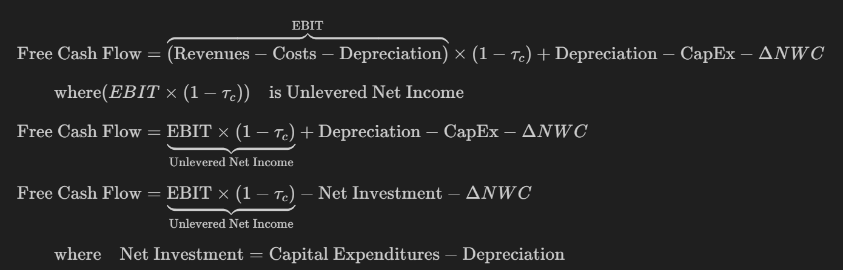

**DCF Valuation Process**

* **Estimate Enterprise Value**

$$V_{0}=PV\left({FCF}_{1},{FCF}_{2},…,{FCF}_{N}, Terminal Value\right)$$

|  |
| --- |
| $$V_{0}=\sum_{t=1}^{N}{\frac{{FCF}_{t}}{{(1+r_{wacc})}^{t}}+\frac{V_{N}}{{(1+r_{wacc})}^{N}}}$$ |

Where $r_{wacc}$ is the Weighted Average Cost of Capital

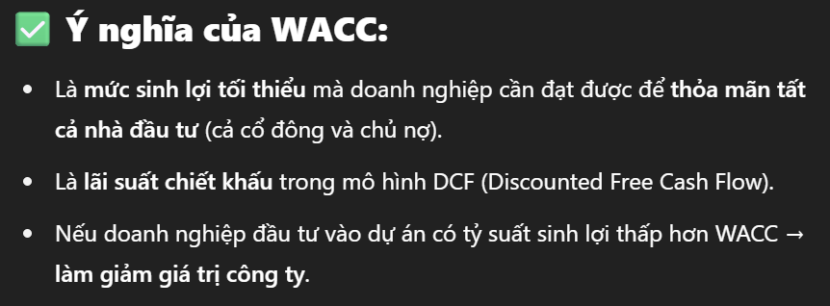

* **Estimate Terminal Value**

|  |
| --- |
| $$V_{N}=\frac{{FCF}_{N+1}}{r_{wacc}- g_{FCF}}=\left(\frac{1+g_{FCF}}{r_{wacc}- g_{FCF}}\right)*{FCF}_{N}$$ |

Where $g_{FCF}$ is long – run growth rate of FCF

* **Calculate Equity Value & Share Price**

|  |
| --- |
| **Equity Value = $V_{0}$– Debt + Cash** |
| $$P_{0}=\frac{Equity Value}{Shares Outstanding}$$ |

* **Weighted Average Cost of Capital (WACC)**
* The average return required by **all investors** (debt + equity).
* If no debt → $r_{wacc}= r_{e}$
* If debt exists → $r_{wacc}= w_{e}*r_{e}+w_{D}*r_{D}*(1-tax)$
* **WACC reflects the overall risk of the firm’s operations.**

1. **Valuation Based on Comparable Firms**

* Valuation multiples are relative valuation tools that compare a firm’s market value to a financial metric (like earnings, revenue, or book value).
* Used to assess **how expensive or cheap** a company is **relative to peers or industry norms**.
* Estimate value by comparing with similar companies.
* **Types of P/E Ratios:**
* Trailing P/E: Uses historical earnings (last 12 months).
* Forward P/E: Uses expected future earnings (next 12 months).

**Price-Earnings (P/E) Ratio**

|  |
| --- |
| $$P/E Ratio=\frac{Price per share}{EPS}$$ |

* Measures: How much investors are willing to pay for $1 of earnings.
* High P/E → market expects high future growth.
* Low P/E → could mean undervaluation or weak growth prospects.
* **Use for**: Comparing firms in the **same industry** with similar accounting policies.

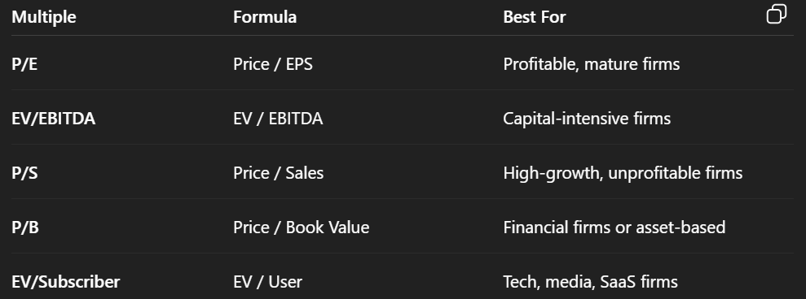

**Link to Dividend-Discount Model (DDM)**

* The forward P/E is derived from the DDM, assuming constant growth (g)

|  |
| --- |
| $$Forward P/E=\frac{P_{0}}{{EPS}_{1}}=\frac{Dividend Payout Ratio}{r_{e}-g}$$ $P_{0}= P/E* EPS$ |

* Dividend Payout Ratio: $\frac{{Div}_{1}}{{EPS}_{1}}$ (portion of earnings paid as dividends).
* $r_{e}$: Cost of equity (required return).
* $g$: Expected growth rate of dividends/earnings.

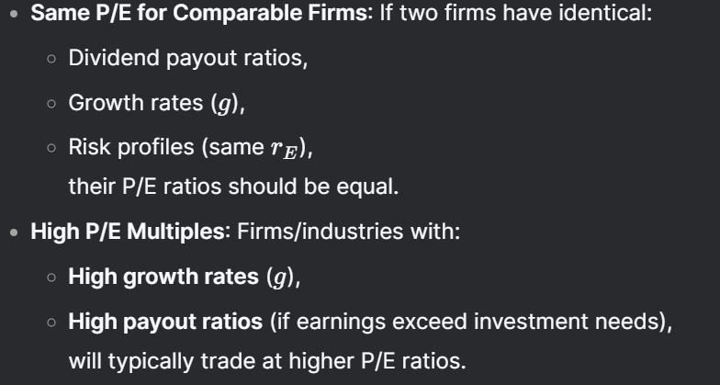

**Key Valuation Multiples Discussed**

* Multiple of sales: Compares a company's market value to its revenue
* Price to book value: Compares market price per share to book value per share
* Enterprise value per subscriber: Used particularly for subscription-based businesses

**Important Limitations of Multiples Valuation**

* **Lack of identical comparables:** No two companies are exactly alike in operations, growth prospects, or risk
* **Relative nature:** Multiples only show value relative to peers, not absolute intrinsic value
* **Different value drivers:** Each multiple emphasizes different aspects (revenue, book value, subscribers)
* **Adjustment challenges:** No standardized method to account for differences between companies

**Stock Valuation Techniques**

* No single technique provides a final answer regarding a stock's true (intrinsic) value.
* All approaches require assumptions or forecasts that are too uncertain to provide a definitive assessment of the firm's value.
* In practice, a combination of these methods is used.

**Enterprise Value Multiples**

* Enterprise Value (EV - $V_{0}$) multiples are widely used in company valuation, especially when comparing firms with different capital structures (debt levels)

**Common EV Multiples:** EV ( $V_{0})$ is compared to pre-interest earnings metrics:

* EV/EBIT: Enterprise Value ÷ Earnings Before Interest and Taxes.
* EV/EBITDA: Enterprise Value ÷ Earnings Before Interest, Taxes, Depreciation & Amortization.

**Linking EV/EBITDA to Discounted Cash Flow (DCF)**

|  |
| --- |
| $$\frac{V_{0}}{{EBITDA}_{1}}=\frac{\frac{{FCF}_{1}}{B{EBITDA}_{1}}}{r_{wacc}-g_{FCF}}$$ |